WORKING WITH DATASET

|  |  |
| --- | --- |
| Project Name | Visualizing and Predicting Heart Diseases with an Interactive Dash  Board |
| Team ID | PNT2022TMID18760 |

**Exploration Of BP Vs Chest Pain Type And Gender**

1. 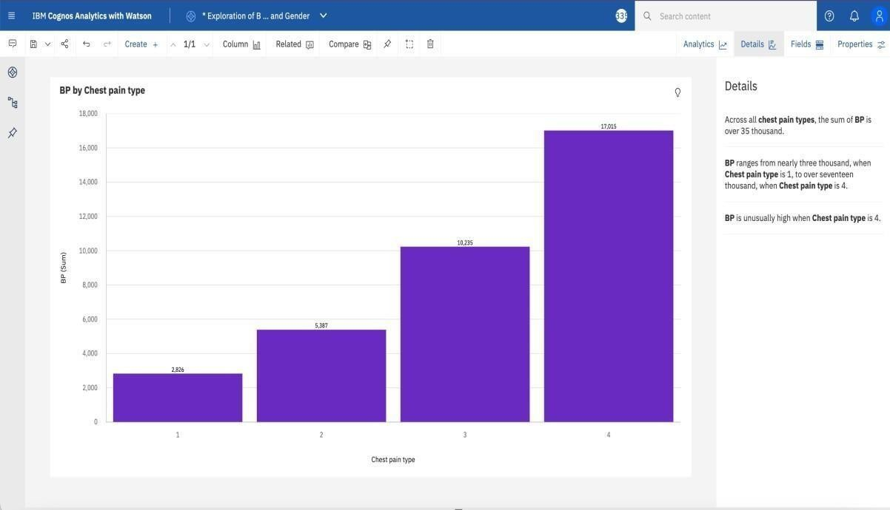BP (sum) by Chest Pain Type:
2. BP (average) by Chest Pain Type:

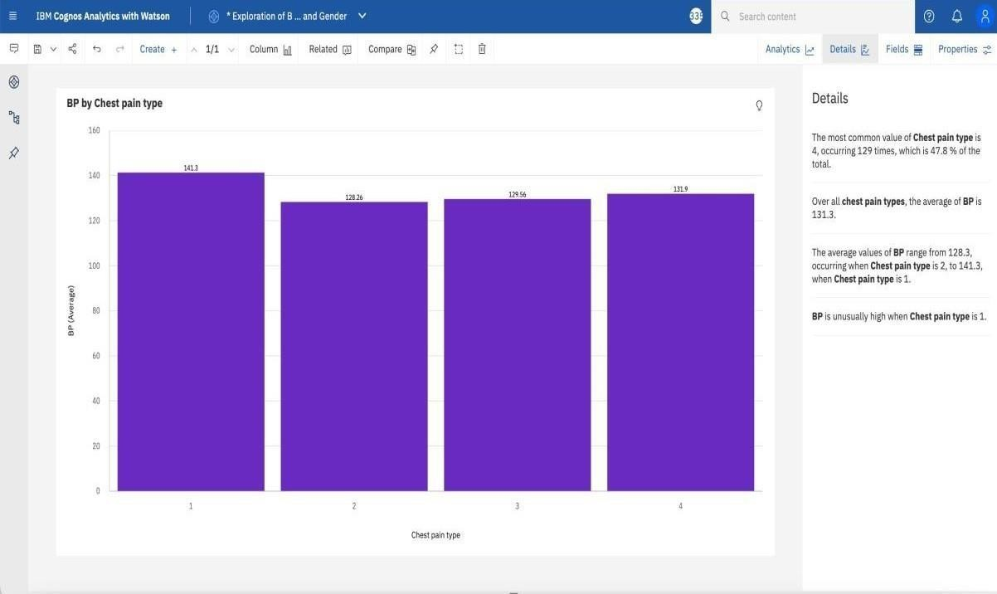

1. 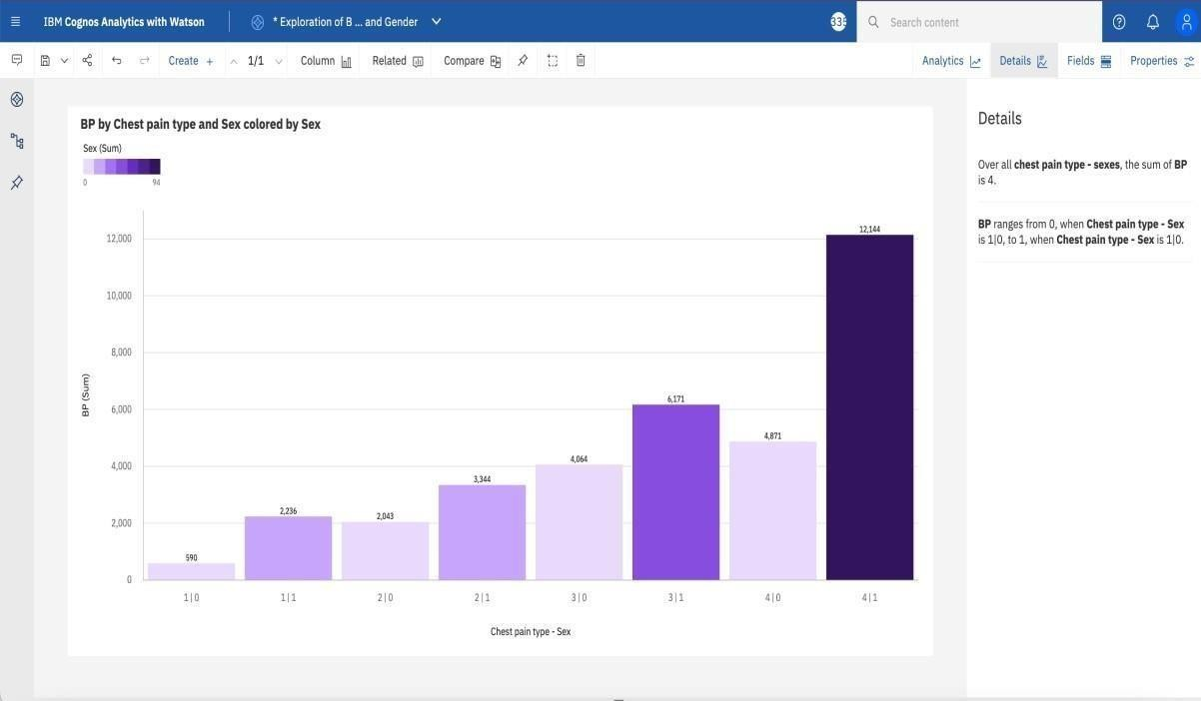BP by Chest Pain Type and Sex(sum) coloured by Sex:
2. BP by Chest Pain Type and Sex(average) coloured by Sex:

